Given n points on a 2D plane, find if there is such a line parallel to y-axis that reflect the given points symmetrically, in other words, answer whether or not if there exists a line that after reflecting all points over the given line the set of the original points is the same that the reflected ones.

Note that there can be repeated points.

**Follow up:**  
Could you do better than O(*n*2) ?

**Example 1:**

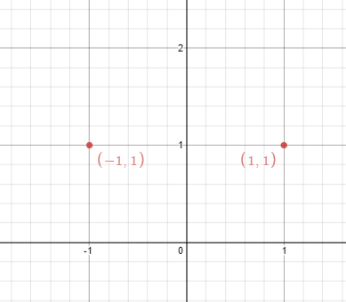

**Input:** points = [[1,1],[-1,1]]

**Output:** true

**Explanation:** We can choose the line x = 0.

**Example 2:**

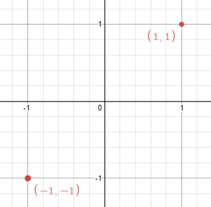

**Input:** points = [[1,1],[-1,-1]]

**Output:** false

**Explanation:** We can't choose a line.

**Constraints:**

* n == points.length
* 1 <= n <= 10^4
* -10^8 <= points[i][j] <= 10^8